Muhammad Hassan raza

C++ program that asks the user to input the following details of a student

student_ID, name, email_address, department, phone_number

Then, save these entered details in a file named “student.txt” and ask the user if he/she wants to enter any new record. If the user enters ‘Y’, then repeat the process again and save/append the newly entered record’s details in the file. If the user enters ‘N’, then the program should exit.

Q1 #include <iostream>

#include <fstream>

using namespace std;

struct Student {

int student_ID;

string name;

string email_address;

string department;

string phone_number;

};

void saveStudentDetails(const Student& student) {

ofstream outputFile("student.txt", ios::app);

if (!outputFile.is_open()) {

cerr << "Error opening file." << endl;

return;

}

outputFile << student.name << '\t' << student.student_ID << '\t' << student.email_address << '\t' << student.department << '\t' << student.phone_number << endl;

outputFile.close();

}

int main() {

char choice;

do {

Student student;

cout << "Enter student details:" << endl;

cout << "Name: ";

cin.ignore(); // Clear the newline character from the buffer

getline(cin, student.name);

cout << "Student ID: ";

cin >> student.student_ID;

cout << "Email Address: ";

cin >> student.email_address;

cout << "Department: ";

cin >> student.department;

cout << "Phone Number: ";

cin >> student.phone_number;

saveStudentDetails(student);

cout << "Record saved. ID: " << student.student_ID << ", Department: " << student.department << ", Phone Number: " << student.phone_number << endl;

cout << "Do you want to enter another record? (Y/N): ";

cin >> choice;

} while (choice == 'Y' || choice == 'y');

return 0;

}

Q1 output:

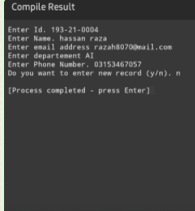

4. C++ program for billing system of a restaurant. The program should perform the following tasks: • Show menu of items/dishes to customers

• It should allow customers to select multiple items (by showing menu again and again continuously until he/she selects the “Quit” option) • Finally, when the customer quits, it should prepare the bill (containing the details of all the orders and the total) and save it in a file named “bills.txt”.

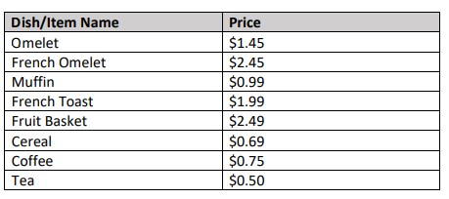

Q5

#include <iostream>

#include <fstream>

#include <iomanip>

#include <map>

using namespace std;

struct MenuItem {

string name;

double price;

};

void showMenu(const map<string, MenuItem>& menu) {

cout << "Menu:" << endl;

for (const auto& item : menu) {

cout << item.first << "\t$" << fixed << setprecision(2) << item.second.price << endl;

}

cout << "Quit\tQuit the order" << endl;

}

void saveBill(const map<string, MenuItem>& menu, const map<string, int>& orders) {

ofstream outputFile("bills.txt");

if (!outputFile.is_open()) {

cerr << "Error opening file." << endl;

return;

}

outputFile << "Bill Details:" << endl;

for (const auto& order : orders) {

outputFile << order.first << "\t$" << fixed << setprecision(2) << menu.at(order.first).price << "\tQuantity: " << order.second << endl;

}

double totalAmount = 0.0;

for (const auto& order : orders) {

totalAmount += menu.at(order.first).price * order.second;

}

totalAmount += (totalAmount * 0.05); // Adding 5% tax

outputFile << "Total Amount (including 5% tax): $" << fixed << setprecision(2) << totalAmount << endl;

outputFile.close();

}

int main() {

map<string, MenuItem> menu = {

{"Omelet", { "Omelet", 1.45 }},

{"French Omelet", { "French Omelet", 2.45 }},

{"Muffin", { "Muffin", 0.99 }},

{"French Toast", { "French Toast", 1.99 }},

{"Fruit Basket", { "Fruit Basket", 2.49 }},

{"Cereal", { "Cereal", 0.69 }},

{"Coffee", { "Coffee", 0.75 }},

{"Tea", { "Tea", 0.50 }}

};

map<string, int> orders;

char choice;

do {

showMenu(menu);

cout << "Enter your choice (or type 'Quit' to finish): ";

cin >> choice;

if (menu.find(choice) != menu.end() && choice != "Quit") {

cout << "Enter quantity: ";

int quantity;

cin >> quantity;

// Update or insert the order

orders[choice] += quantity;

} else if (choice != "Quit") {

cout << "Invalid choice. Please select an item from the menu." << endl;

}

} while (choice != "Quit");

saveBill(menu, orders);

cout << "Bill saved successfully." << endl;

return 0;

}

